Connor McGuire

Inception Planning

Contents

Brief 2

Functional & non-functional 2

Functional Requirements 2

Non-functional requirements 3

Initial Use Case Model 4

Information gathered 6

Aims of Project 8

Resources 8

Bibliography 10

Figure 1 4

Figure 2 5

# Brief

I have been tasked with creating a simple application for Simply Football. This system should ultimately track members and their training profiles, along with training sessions and games that have been undertaken.

Simply Football has a large club membership, so all the members must be registered accordingly and grouped by their membership.

This system should be a great help for the club to determine which players should be put forward for development activities and where players can reach their full potential in their position.

# Functional & non-functional

## Functional Requirements

- Main simple football window

-Must be able to navigate to and from each other window

-Must have a log in section

- Player details window

-Should be able to navigate back to main window

-Should distinguish between player, Non-players and youth forms

-Should be able to add in new players

-Should be able to update/edit/delete player details

-Youth players must have a guardian

-Must be given a unique SFA number

- Player profiles window

-Should be able to navigate back to main window

-Stores player name and season

-Stores a range of skills for each player

-Allows coach to add/edit skill level points

-Can store comments about each skill

-Can add/delete skill categories

- Game Details window

-Should be able to navigate back to main window

-Be able to add and edit games

-System should record opposition name, date of match, location, k/o time, Result, Score

-Should be able to record first half and second with scores and comments, goals for and goals against

- Training session details window

-Should be able to navigate back to main window

-Should be able to Add/edit/Delete Training record sheets

-Should track coach organisation, Date, time, Location

- Should track all players that attended

-Track injuries/Accidents

-Should track skills and activities undertaken

## Non-functional requirements

When talking to the client, he told me there were no requests for certain constraints/considerations for look/style/languages/reasonable adjustments. With that being said, I have come up with these non-functional requirements.

-Storing details should be within the confinements of GDPR

-Relevant info can be sent to all members when needed

-Navigation should be easy to view

-Could possibly use a database

-Have a good response time overall

-User friendly

# Initial Use Case Model

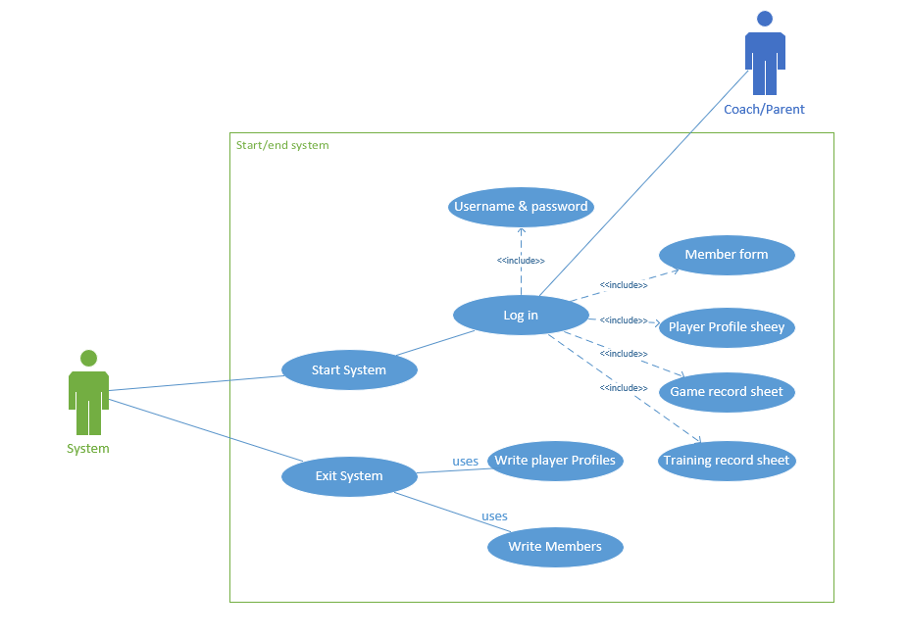

Figure 1

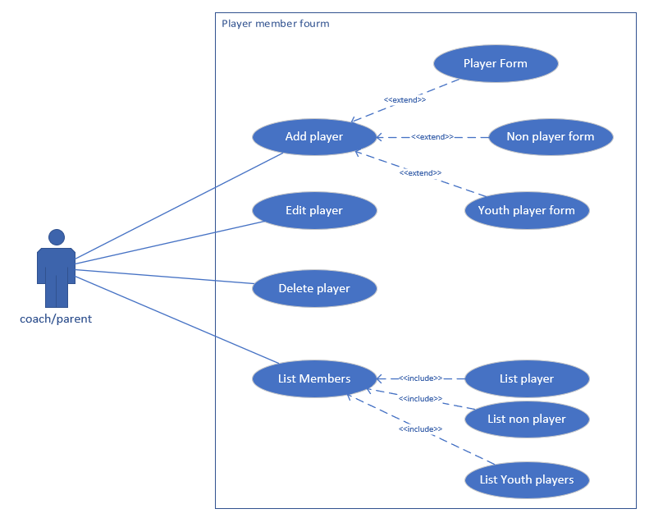

Figure 2

# Information gathered

Soon after I got the initial project brief I decided to Email the club chairman, Mr Peter Ainsworth, So I could gather as much information as possible and to ask specific questions that I had about the programme and the scale of the project.

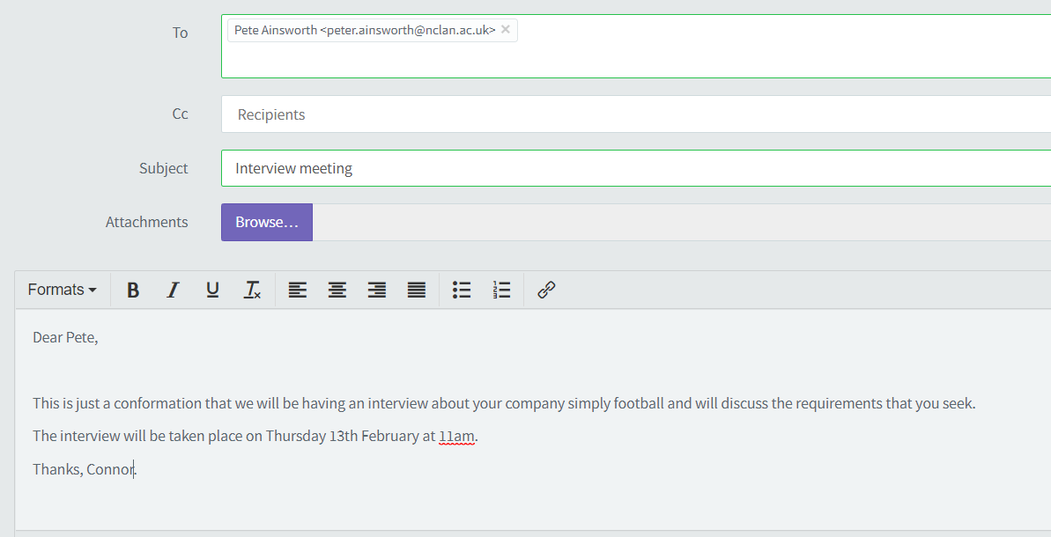

I had to Write out a list of questions for peter and had a successful interview. Some of the answers I got back are as followed:

1. Can you give me a summary of the overall application?

Range of levels junior, senior club, youth development, improve training schedule, most important in training session dribbling, passing, shooting, heading, no heading in junior, any addition skills SFA website. Keep track of skills, keep track of weak areas. Maybe not number chart but bar for skills (parents won’t see skills) can add new categories in. Develop skills are most important so we need to track this with the players.

-Tracking games not that important for now.

-Amount of training taken place.

1. Who will be allowed to access the information? Will there have to be a log in process.

Legally need to put in log in process (coaches’ access) kids enrol in, needs to have a membership.

1. Any design constraints/consideration for the app? (look/style/languages/reasonable adjustments (disabilities)).

No constraints. Could use database or not.

Players

1. Is it just the one team or multiple?

One club

1. Will the coaches need to be tracked?

Don’t need to be tracked.

1. What are the different age groups of players?

Range of levels junior, senior club, youth development

1. What kind of details will need to be held for each player?

See Detailed sheet.

1. What are the different skill training players can have/do?

See detailed sheet (short pass, long pass, shoot, header, slide tackle, shoulder tackle, dribbling)

1. Will the app track games that have played?

Could do but not a main requirement at this point

Final questions

1. Any additional features for the future and why?

Add whatever seems fit, skills should be unavailable and editable. Heading not allowed in junior, rules can change. Can put in own logo.

1. Any additional documentation.

Detailed sheet

Along with this interview, Peter gave me a detailed scenario detailing:

Club overview, a description of how the club is ran and different sectors.

Player details – documenting the player, youth and non-player member form. This included such features such as the players information, Doctor information, position. The youth form also had a section for guardians.

Player profile sheet – This included the certain players skills on a rank from 1-5. Skills included were short pass, long pass, shoot, header, slide tackle, shoulder tackle, dribbling. With the option to add comments along with the season number.

Game sheet record – That recorded the details of each game of the season, scores and additional comments on how each half went.

Training record sheet – This recorded each training session that had taken place, skills activated performed, players attendance and accidents and injuries.

Along with this, I have decided to adopt the waterfall methodology. I Have found this to be the most suitable methodology for this project as its very basic to follow, there are five main stages (Requirement analysis, design, implementation, testing, maintenance) and you must complete each stage completely before moving on to the next in a linear process. I thought this would be the most appropriate methodology to use as this will be the first major system ill be creating so the simpler the development process is, the easier it will be for me to follow. Also, when following my project plan it’ll be easier to track the deadlines that will arise. (Powell-Morse, 2016)

# Aims of Project

Personally, my own aims for this project is to create a fully functional system that has adhered to the software specification and requirements, to follow the waterfall methodology and see how well It works in a project like this. I also want to make sure I have the system complete within time constraints, so the client can the system working at the time frame we discussed.

For the client, I aim on developing a user-friendly programme that the user can easy navigate and store their players information on one system. I hope to follow the client’s needs and objectives as closely as possible so that they are fulfilled and if I have time to spare, maybe add in some additional features too. (Team Clarizen , 2018)

# Resources

I will be using a wide range of resources and materials to complete this project. Some of the following are:

* Visual studios which I have downloaded for free and will be used as my development environment.
* The C# coding language will be the only language used throughout this project.
* Home laptop/college computer, so I have the flexibility to work on the project at home on my laptop or whilst I’m at college on their PC’s.
* One drive, this is a cloud operated system where ill be storing the project, so I can open the files on any device I choose.
* MS project, which is also a free software platform. I’ll be using this to keep track of dates and deadlines by using a Gantt chart.
* Microsoft word to document the project information (interviews, google links etc) and for the testing documentation.
* Information from simply football and their chairman to accurately depicted the system that they are looking for. I will be communicating through in person interviews and by email if I have any questions.
* Google chrome/internet so I can look up any additional information that’s needed at that time.

# Bibliography

(Team Clarizen , 2018) - <https://www.clarizen.com/objectives-of-project-management/>

(Powell-Morse, 2016) - <https://airbrake.io/blog/sdlc/waterfall-model>